This file acts as a companion to the code for enhancement three, databases, within the final project for CS-499. It exists to demonstrate the commands that were utilized within the MongoDB terminal using SQL as a programming language to execute the use of triggers on the database.

First, we navigate to the correct database and create a table to capture the changes made within the database. It contains the fields within the database as well as an id for each entry in the new table, changeOccurred to capture when the change took place, changeBy to record which user performed the change, and changeType to record what kind of change it was.

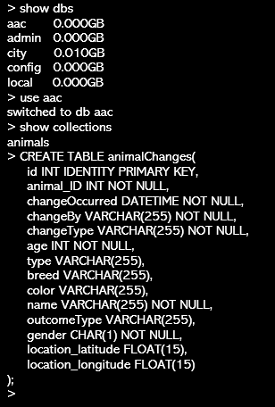

Next, we create the first trigger, for the creation of a new record to the database. It will act based on changes to the “animals” collection. “Set nocount on” is used to reduce network traffic and prevent a message from being returned for each statement. A username variable is declared, and the current user is assigned to that variable. Then, the values are inserted into the table based on what is entered. The now() function is used to generate a datetime for the ChangeOccurred value. The username variable is used for the changeBy value. A string that states “insert” is used for changeType.

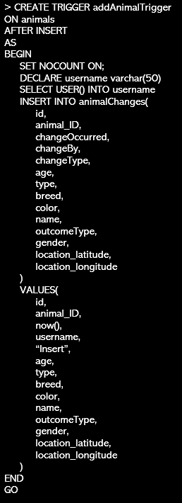

Then, we create the next trigger, for the update of an existing record in the database. It is similar to the first trigger, but is triggered before an update is processed. Additionally, the “old.” operator is used before entries to record their status before the update. The changeType is also recorded as “Update” rather than “Insert”.

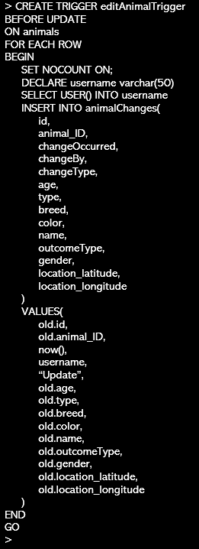

Finally, we create the last trigger for deleting an entry from the database. This follows the same format as the other two triggers, with the exception of occurring before an entry is deleted, and the changeType is recorded as “delete”.

